- Label Studio

Install Label Studio

Label Training data

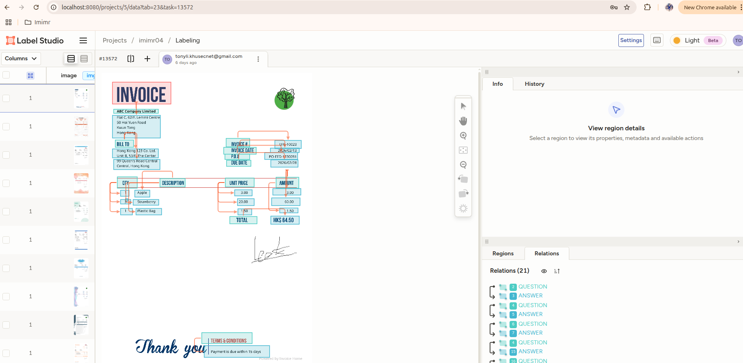

Export JSON Data File

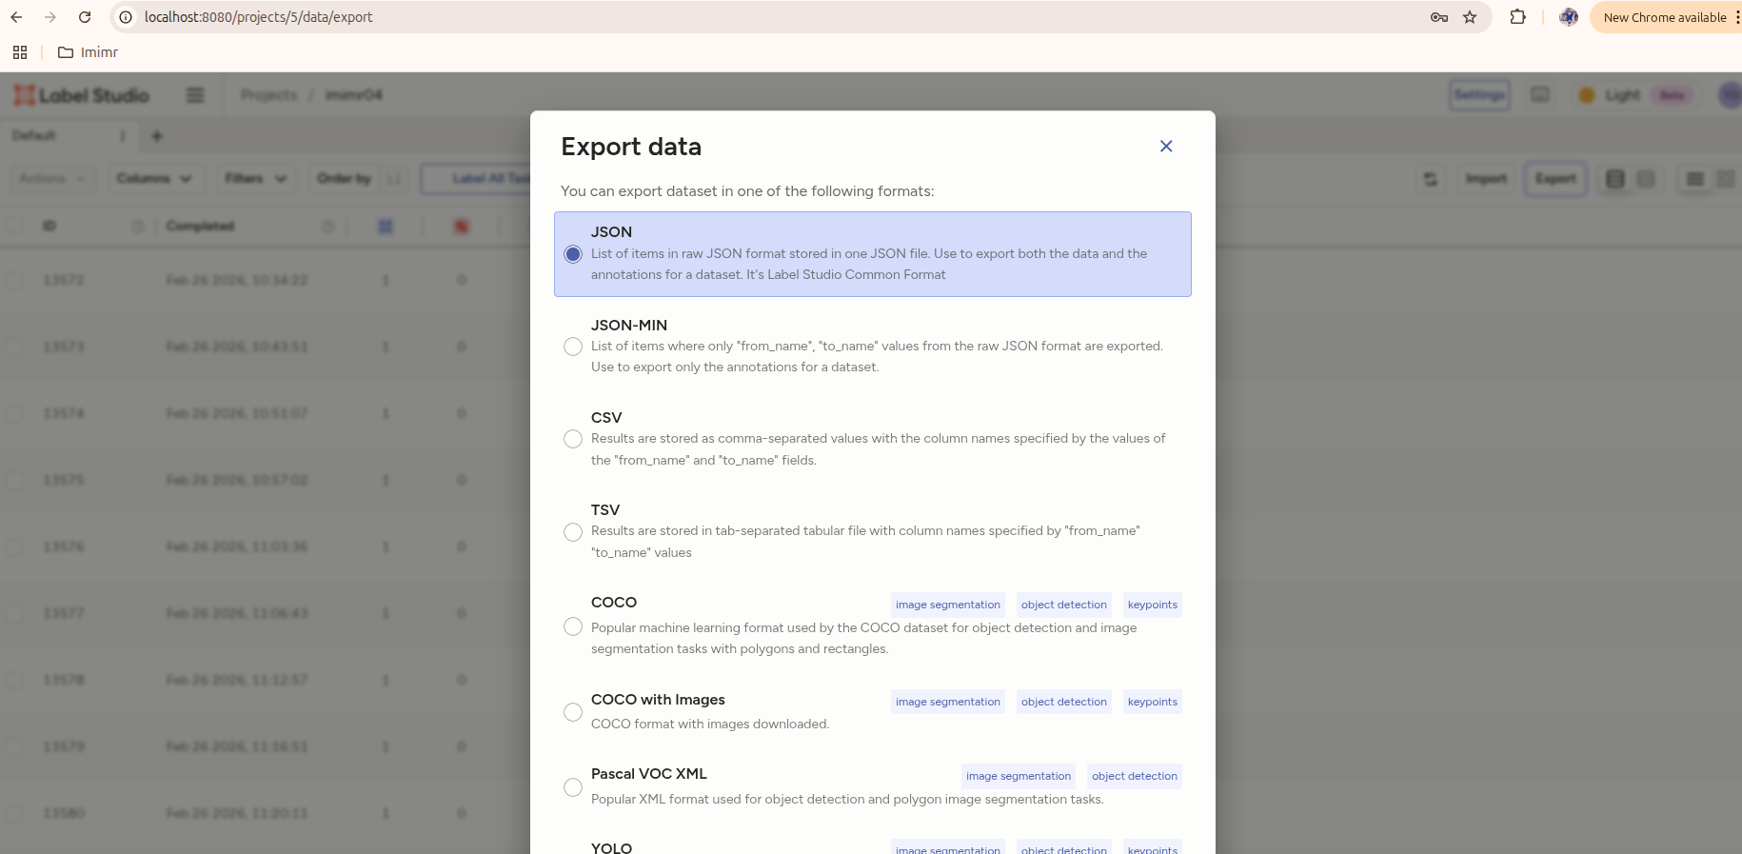

- Install LILT Git

git clone https://github.com/jpWang/LiLT

cd LiLT

Change requirements.txt as follows:
======================
datasets>=2.10.1
transformers>=4.38.2
seqeval==1.2.2
==================

pip install -r requirements.txt

pip install -e .

- Generate the training data

Copy gen_data.py to /LiLT directory

Install requirements.txt
==========================
# Core PyTorch ecosystem (adjust CUDA version as needed)
torch>=2.0.0
torchvision>=0.15.0

# Transformers & LayoutLMv3
transformers>=4.37.0
accelerate>=0.25.0

# Data handling
numpy>=1.24.0
pandas>=2.0.0

# Image processing
Pillow>=9.5.0
opencv-python>=4.8.0

# OCR (for LiLT inference/training preprocessing)
easyocr>=1.7.0
pytesseract>=0.3.10
pdf2image>=1.16.0 # For PDF support

# Utilities
tqdm>=4.65.0
scikit-learn>=1.3.0 # For metrics/splitting if needed

# Optional: Weights & Biases for experiment tracking
# wandb>=0.15.0

# Optional: TensorBoard
tensorboard>=2.14.0

==========================

Create directory - nielsr/img and nielsr/fund

Copy image to img directory

Copy pdf to fund directory

python # 80% train, 20% validation
python convert_fund.py export.json ./images/ ./lilt_data/ --val-ratio 0.2

test is output training data directory

- Generate the training data

Copy models to examples directory

Install requirements.txt
# ====================================================================

# Core PyTorch ecosystem (adjust CUDA version as needed)
torch>=2.0.0
torchvision>=0.15.0

# Transformers & LayoutLMv3/LiLT
transformers>=4.37.0
accelerate>=0.25.0

# Data handling
numpy>=1.24.0
pandas>=2.0.0

# Image processing
Pillow>=9.5.0
opencv-python>=4.8.0

# OCR (for inference preprocessing)
easyocr>=1.7.0
pytesseract>=0.3.10
pdf2image>=1.16.0

# Metrics & utilities
scikit-learn>=1.3.0
tqdm>=4.65.0

# Optional: Weights & Biases for experiment tracking
# wandb>=0.15.0

# Optional: TensorBoard
tensorboard>=2.14.0

==================================

Training model and output directory is lilt_model
# Custom hyperparameters for better convergence
python train_lilt_invoice.py \
--train_dir lilt_dataset/train \
--val_dir lilt_dataset/val \
--images_dir new_form \
--output_dir lilt_model_10 \
--model_name SCUT-DLVCLab/lilt-roberta-en-base \
--epochs 130 \
--batch_size 1 \
--learning_rate 5e-5 \
--warmup_ratio 0.1 \
--gradient_accumulation_steps 8 \
--weight_decay 0.01 \
--relation_loss_weight 0.3 \
--max_entity_pairs 64 \
--eval_steps 50 \
--seed 42

- Run the script

Copy document_analysis.py and extract_field.py to LiLT

Install requirements.txt
==============================

# Core PyTorch ecosystem (adjust CUDA version as needed)
torch>=2.0.0
torchvision>=0.15.0

# Transformers & LayoutLMv3
transformers>=4.37.0
accelerate>=0.25.0

# Data handling
numpy>=1.24.0
pandas>=2.0.0

# Image processing
Pillow>=9.5.0
opencv-python>=4.8.0

# OCR (for inference preprocessing)
easyocr>=1.7.0
pytesseract>=0.3.10
pdf2image>=1.16.0 # For PDF support

# Utilities
tqdm>=4.65.0

# Optional: For development/debugging
# ipython>=8.0.0
# matplotlib>=3.7.0
=================================

Run the script
# Run inference on a single invoice image
python lilt_inference.py \
./invoice.pdf \
--model ./lilt_model \
--output ./results

